Homework #5 Solutions
Integer Programming

6-18. There are 8 decision variables (A, H, E, N, S, M, B, and R) corresponding to the eight investment options. Each variable can take only one of two values: = 1 if the investment is chosen, and = 0 if it is not.

Objective: Maximize total return = Sum of (Return per investment * Investment DV)

Subject to:
$500A | + $1,000H | + $350E | + $490N | + $700S | + $270M | + $800B | + $400R | ≤ | $3,000 | Cost ($'000)
A | + H |  |  |  |  |  |  | ≤ | 1 | Bond
 |  | E | + N | + S |  |  |  | ≥ | 2 | Utility
 |  |  |  |  | M | + B | + R | ≥ | 2 | Regular
A | + H | + E | + N | + S | + M | + B | + R | ≥ | 5 | Total
 |  |  |  |  |  | All | vars | = | 0, 1 | Binary

Solution: See file P6-18.XLS.
 | Ando-ver | Hamil-ton | Easy | Nebraska | South-ern | Man-uel | Build-ers | Rest
Invest? (1 = Yes) | 0 | 1 | 1 | 1 | 0 | 1 | 1 | 0
Exp return ($'000) | $50 | $100 | $30 | $45 | $65 | $20 | $90 | $35 | $285.0

6-19. There are 7 binary decision variables (A to G) corresponding to the seven investment options. Each variable can take only one of two values: = 1 if the investment is chosen, and = 0 if it is not.

Objective: Maximize total return = Sum of (Return per investment * Investment DV)

Subject to:
$5.0A | + $8.0B | + $3.5C | + $10.0D | + $8.5E | + $12.0F | + $4.0G | ≤ | $30 | $ available ($'000)
 |  |  |  |  | F |  | ≤ | G | F and G
A | + B | + C | + D | + E | + F | + G | ≥ | 4 | At least 4
A | + B |  |  |  |  |  | = | 1 | A and B
A, | B, | C, | D, | E, | F, | G | = | 0, 1 | Binary

Solution: See file P6-19.XLS.
 | A | B | C | D | E | F | G
Selected? (1 = yes) | 1 | 0 | 0 | 0 | 1 | 1 | 1
Return | $500 | $640 | $390 | $700 | $750 | $1,000 | $300 | $2,550.0

6-22. There are 6 binary decision variables (P₁ to P₆) corresponding to the six projects. Each variable can take only one of two values: = 1 if the project is chosen, and = 0 if it is not.

Objective: Maximize total NPV = Sum of (NPV * Project DV)

There are six constraints: one for each year’s R&D budget.

Solution: See file P6-22.XLS.
 | P₁ | P₂ | P₃ | P₄ | P₅ | P₆
Selected? (1 = yes) | 0 | 0 | 0 | 1 | 1 | 1
NPV ($'000) | $182 | $167 | $114 | $98 | $250 | $130 | $478.0

6-25. This problem describes two types of decisions. Georgia Atlantic must decide where to build the two new warehouses and which warehouse to use to ship product to each of the three markets. There are a total of 16 decision variables. Four of them are binary, corresponding to the location of the new warehouses. These can take only one of two values, = 1 if the city is chosen for a warehouse and = 0 if it is not. The other twelve variables are regular variables, corresponding to the amounts to be shipped from each potential warehouse to each of the three markets.

Objective: Minimize total costs = Fixed cost + Shipping cost
The objective function will have 16 terms in it, the fixed cost of each potential warehouse location multiplied by its binary decision variable, plus 12 terms for shipping costs.

There are eleven constraints: one constraint that limits the number of new warehouses to 2, four capacity constraints, one constraint for each potential warehouse, three demand constraints, one constraint for each market, a Philadelphia/Denver constraint, a Tampa Bay/Chicago constraint, and non-negativity.

Solution: See file P6-25.XLS.
 | Regular variables
 | PN | PS | PW | TN | TS | TW | CN | CS | CW | DN | DS | DW
Solution value | 200 | 50 | 0 | 0 | 0 | 0 | 0 | 0 | 0 | 0 | 130 | 120
Cost | $4 | $7 | $9 | $6 | $3 | $11 | $5 | $6 | $5 | $8 | $10 | $2

 | Binary variables
 | P | T | C | D
Solution value | 1 | 0 | 0 | 1
Cost | $1,000 | $800 | $1,200 | $700 | $4,390

6-17. Let A = number of $10 bills to use. B, C, D, E, F, and G defined similarly.

Objective: Minimize total used = A + B + C + D + E + F + G

Subject to:
10A | + 5B | + C | + 0.25D | + 0.10E | + 0.05F | + 0.01G | = | 22.98 | Amount required
A |  |  |  |  |  |  | ≤ | 1 | $10 available
 | B |  |  |  |  |  | ≤ | 4 | $5 available
 |  | C |  |  |  |  | ≤ | 1 | $1 available
 |  |  | D |  |  |  | ≤ | 8 | $0.25 available
 |  |  |  | E |  |  | ≤ | 1 | $0.10 available
 |  |  |  |  | F |  | ≤ | 5 | $0.05 available
 |  |  |  |  |  | G | ≤ | 6 | $0.01 available
A, | B, | C, | D, | E, | F, | G | ≥ | 0 | Non-negativity

Solution: See file P6-17.XLS.
 | $10 | $5 | $1 | $0.25 | $0.10 | $0.05 | $0.01
Number used | 1.0 | 2.0 | 1.0 | 7.0 | 1.0 | 2.0 | 3.0
Total items | 1 | 1 | 1 | 1 | 1 | 1 | 1 | 17.00

6-21. There are 8 binary decision variables (A to H) corresponding to the eight pitchers. Each variable can take only one of two values: = 1 if the pitcher is chosen, and = 0 if he is not.

Objective: Maximize total value = Sum of (Value of pitcher * Pitcher DV)

There are five constraints: total budget, number of right-handers, number of left-handers, number of starters, and number of relievers.

Solution: See file P6-21.XLS.
 | A | B | C | D | E | F | G | H
Selected? (1 = yes) | 1 | 0 | 0 | 0 | 1 | 1 | 0 | 0
Value | 4 | 5 | 6 | 5 | 8 | 5 | 7 | 8 | 17.0

Homework #5 (Extra Problems)
Integer Programming

Problem 1

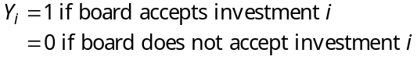
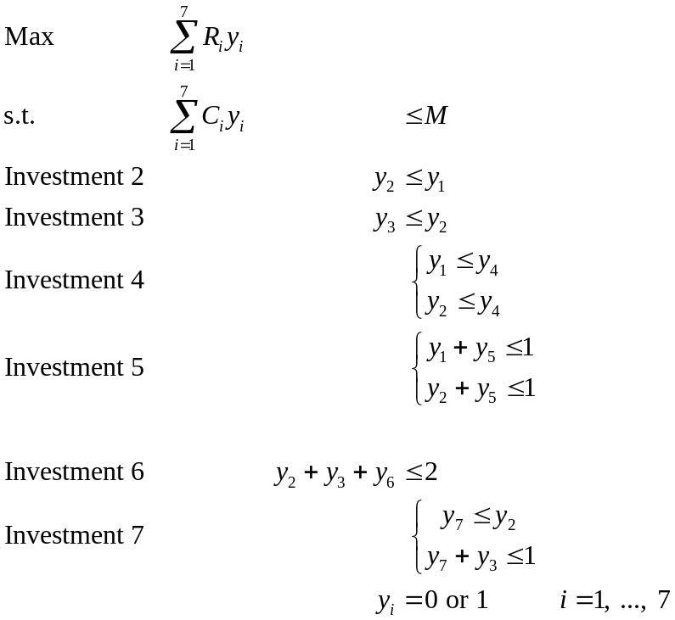

Problem 2

Let

A,B,C,D =1 if A, B,C,D is chosen
=0 otherwise
Y₁= 1 if A, B, C is chosen together
=0 otherwise
Y₂ = 1 if A, C, D is chosen
= 0 otherwise
Y₃ =1 if B,C,D is chosen
= 0 otherwise

Then the ILP may be formulated as:

Min
s.t. 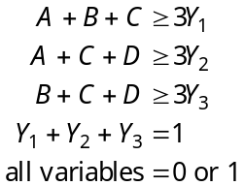

Problem 3
Let A = number of $10 bills to use. B, C, D, E, F, and G defined similarly.

Objective: Minimize total used = A + B + C + D + E + F + G

Subject to:

10A | + 5B | + C | + 0.25D | + 0.10E | + 0.05F | + 0.01G | = | 22.98 | Amount required
A |  |  |  |  |  |  | ≤ | 1 | $10 available
 | B |  |  |  |  |  | ≤ | 4 | $5 available
 |  | C |  |  |  |  | ≤ | 1 | $1 available
 |  |  | D |  |  |  | ≤ | 8 | $0.25 available
 |  |  |  | E |  |  | ≤ | 1 | $0.10 available
 |  |  |  |  | F |  | ≤ | 5 | $0.05 available
 |  |  |  |  |  | G | ≤ | 6 | $0.01 available
A, | B, | C, | D, | E, | F, | G | ≥ | 0 | Non-negativity

Solution:
 | $10 | $5 | $1 | $0.25 | $0.10 | $0.05 | $0.01
Number used | 1 | 2 | 1 | 7 | 1 | 2 | 3
Total items | 1 | 1 | 1 | 1 | 1 | 1 | 1 | 17.00

Problem 4
This problem describes two types of decisions. Georgia Atlantic must decide where to build the two new warehouses and which warehouse to use to ship product to each of the three markets. There are a total of 16 decision variables. Four of them are binary, corresponding to the location of the new warehouses. These can take only one of two values, = 1 if the city is chosen for a warehouse and = 0 if it is not. The other twelve variables are regular variables, corresponding to the amounts to be shipped from each potential warehouse to each of the three markets.

Objective: Minimize total costs = Fixed cost + Shipping cost
The objective function will have 16 terms in it, the fixed cost of each potential warehouse location multiplied by its binary decision variable, plus 12 terms for shipping costs.

There are eleven constraints: one constraint that limits the number of new warehouses to 2, four capacity constraints, one constraint for each potential warehouse, three demand constraints, one constraint for each market, a Philadelphia/Denver constraint, a Tampa Bay/Chicago constraint, and non-negativity.

Min. 4PN+7PS+9PW+6TN+3TS+11TW+5CN+6CS+5CW+8DN+10DS+2DW+1000P+800T+1200C+700D
s.t. PN+PS+PW≤ 250P
TN+TS+TW≤ 260T
CN+CS+CW≤ 280C
DN+DS+DW≤ 260D
P+D≥1
T≤C

Solution

 | Regular variables
 | PN | PS | PW | TN | TS | TW | CN | CS | CW | DN | DS | DW
Solution value | 200 | 50 | 0 | 0 | 0 | 0 | 0 | 0 | 0 | 0 | 130 | 120
Cost | $4 | $7 | $9 | $6 | $3 | $11 | $5 | $6 | $5 | $8 | $10 | $2

 | Binary variables
 | P | T | C | D
Solution value | 1 | 0 | 0 | 1
Cost | $1,000 | $800 | $1,200 | $700 | $4,390

